
Year 8

Investigation

Woodman’s Point
Calculator allowed

Total Marks: 17 marks
Name: ______________________ Total Time: 20 minutes

A group of students are conducting an experiment to determine what bins are required at Woodman’s point.

- (5 marks)
The students recorded the location of where they found the following items at Woodman’s point. Using the location coordinates from the table, plot on the map where each of the items of rubbish was found.

Item | Location (x,y)
- Glass bottles | (10, 1)
- Paper bags | (2, -3)
- Food scraps | (-5, -6)
- Aluminium Cans | (0, -3)
- Plastic bags | (-8, -5)

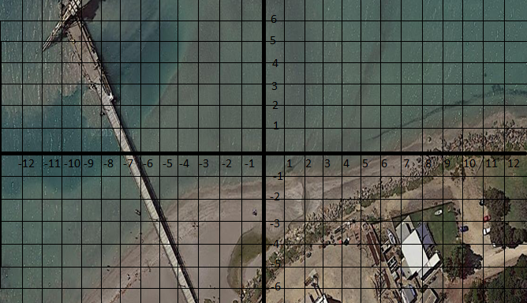

- (8 marks)
The rubbish collected was placed in to the following containers.

Complete the following table. (Hint: 1L = 1000$cm^{3}$)

Type of Material | Container | Volume ($cm^{3}$) | Capacity (L)
Recyclables | 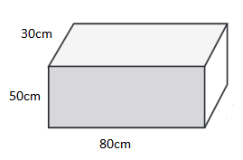
General waste | 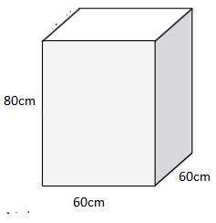

- If they filled the Recyclables container 3 times, estimate how much recyclables were collected. Give your answer in litres.

- If they filled the General waste container 5 times, estimate how much general waste was collected. Give your answer in Litres.

- (4 marks)
The bins that they plan on using for Woodman’s point have a capacity of 240L. If both recycling and general waste bins are the same size determine;

  - How many recycling bins would be required to dispose of the recyclable rubbish?

  - How many general waste bins would be required to dispose of the general waste rubbish?

